1. Event Diagram

|  |  |  |  |  |  |
| --- | --- | --- | --- | --- | --- |
| Event | Trigger | Source | Use Case | Response | Destination |
| User wants to login to the system | Login | User | User Login | Successfully logged in | User |
| Admin wants to login to the system | Login | Admin | Admin Login | Successfully logged in | Admin |
| Creating violation | Student violation | Admin | Create violation report | Violation created | System |
| Notification of violation | Stores violation data | System | Notification of violation | Receives notification of violation | User |
| Viewing of violations | View all violations | User | View all my violations records | Display all violations | User |
| Viewing all violation reports | View all violation records | Admin | View all violation records | Display all violation reports | Admin |
| View issued violation reports | Submit violation report | Admin | View issued violation reports | Display all issued violation reports | Admin |
| Correction of violation | Student reported wrong violation report | Admin | Update violation report | Updates violation report | System |
| Cancellation of violation | Mistake in violation | Admin | Cancel violation | Violation deleted | System |

1. 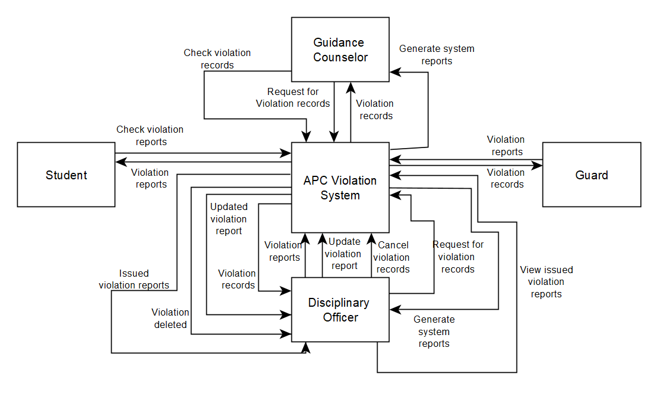Data Flow Diagram (Context diagram & Diagram

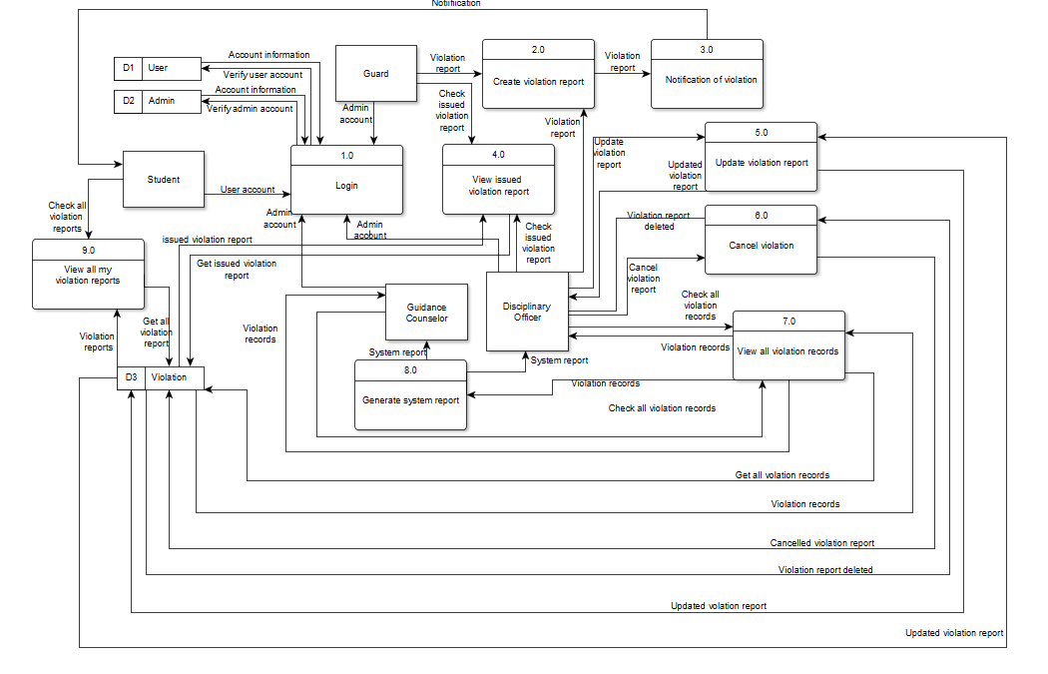

1. Use Case & Use Case Full Description 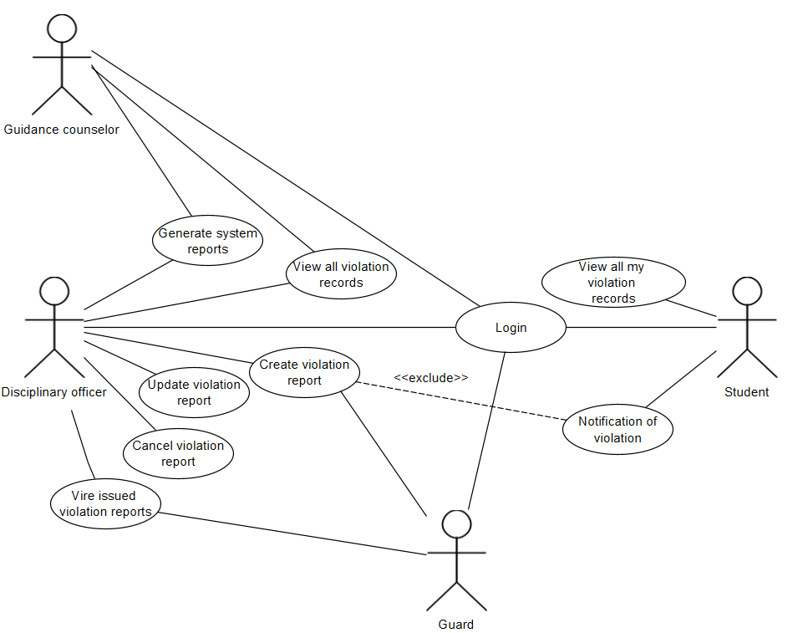

|  |  |  |
| --- | --- | --- |
| Use Case Name | User Login | |
| Scenario | User wants to login to the system | |
| Triggering Event | Login | |
| Brief Description | User wants to login in APC Violation System | |
| Actors | Student | |
| Related Use Case | Admin Login | |
| Stakeholders | Student | |
| Preconditions | * Student must have installed the APC Violation System on his/her device * Student must have the link of APC Violation System site. * Student must have internet connection * Student must have account in APC | |
| Postconditions | Student will go directly to the main page | |
| Flow of Activities | Actor | System |
| 1. Student opens the APC Violation System application |  |
|  | * 1. System display sign-in form |
| 1. Student fills out the sign in form |  |
|  | 2.1 System accepts the user information and verified it in the system’s database |
|  | 2.2 System display APC  violation system main page |
| Exception Conditions | * Student has not installed the application in the device * Student has no internet connection * Student has no account in APC * Student has wrong credentials | |

|  |  |  |
| --- | --- | --- |
| Use Case Name | Admin Login | |
| Scenario | Admin wants to login to the system | |
| Triggering Event | Login | |
| Brief Description | Admin wants to login in APC Violation System | |
| Actors | Guidance Counselor, Disciplinary Officer, Guard | |
| Related Use Case | User Login | |
| Stakeholders | Guidance Counselor, Disciplinary Officer, Guard | |
| Preconditions | * Guidance Counselor, Disciplinary Officer, and Guard must have installed the APC Violation System on his/her device * Guidance Counselor, Disciplinary Officer, and Guard must have the link of APC Violation System site. * Guidance Counselor, Disciplinary Officer, and Guard must have internet connection * Guidance Counselor, Disciplinary Officer, and Guard must have account in APC | |
| Postconditions | Guidance Counselor, Disciplinary Officer, and Guard will go directly to the main page | |
| Flow of Activities | Actor | System |
| 1. Guidance Counselor, Disciplinary Officer, and Guard opens the APC Violation System application |  |
|  | * 1. System display sign-in form |
| 1. Guidance Counselor, Disciplinary Officer, and Guard fills out the sign in form |  |
|  | 2.1 System accepts the admin information and verified it in the system’s database |
|  | 2.2 System display APC  violation system main page |
| Exception Conditions | * Guidance Counselor, Disciplinary Officer, and Guard has not installed the application in the device * Guidance Counselor, Disciplinary Officer, and Guard has no internet connection * Guidance Counselor, Disciplinary Officer, and Guard has no account in APC * Guidance Counselor, Disciplinary Officer, and Guard has wrong credentials | |

|  |  |  |
| --- | --- | --- |
| Use Case Name | Create violation report | |
| Scenario | Admin wants to create a violation report | |
| Triggering Event | Student violation | |
| Brief Description | Admin wants to submit a report in the system | |
| Actors | Disciplinary Officer, Guard | |
| Related Use Case |  | |
| Stakeholders | Disciplinary Officer, Guard | |
| Preconditions | * Disciplinary Officer and Guard must have installed the APC Violation System on his/her device * Disciplinary Officer and Guard must have the link of APC Violation System site. * Disciplinary Officer and Guard must have internet connection * Disciplinary Officer and Guard must have logged in to the system | |
| Postconditions | Violation report will go directly to the issued violation report | |
| Flow of Activities | Actor | System |
| 1. Disciplinary Officer and Guard clicks create a violation report |  |
|  | * 1. System display violation report form |
| 1. Disciplinary Officer and Guard fills out the violation report form |  |
|  | 2.1 System accepts the violation report information and inserted it in the system’s database |
| Exception Conditions | * Disciplinary Officer and Guard has not installed the application in the device * Disciplinary Officer and Guard has no internet connection * Disciplinary Officer and Guard has not logged in to the system * Disciplinary Officer and Guard has not filled required information | |

|  |  |  |
| --- | --- | --- |
| Use Case Name | Notification of violation | |
| Scenario | System updates the student and parent regarding the violation | |
| Triggering Event | Stores violation data | |
| Brief Description | System will automatically notify the student and his/her parent regarding his/her violation. | |
| Actors | System | |
| Related Use Case |  | |
| Stakeholders | System | |
| Preconditions | * Disciplinary Officer and Guard must have submitted a violation report * Disciplinary Officer and Guard must have internet connection | |
| Postconditions | Both student and parent will get a notification sent by the system | |
| Flow of Activities | Actor | System |
|  | 1. System’s database receives violation report |
|  |  | 1. Send violation information to the Student and Parent |
| Exception Conditions | * Disciplinary Officer and Guard has not filled violation report * Disciplinary Officer and Guard has no internet connection | |
| Use Case Name | View all my violation records | |
| Scenario | Student wants to see his/her violations | |
| Triggering Event | View violation reports | |
| Brief Description | Student wants to check his/her violations | |
| Actors | Student | |
| Related Use Case | View all violation records | |
| Stakeholders | Student | |
| Preconditions | * Student must have installed the APC Violation System on his/her device * Student must have the link of APC Violation System site. * Student must have internet connection * Student must have logged in to the system | |
| Postconditions | Display all violation reports | |
| Flow of Activities | Actor | System |
| 1. Student clicks view all violation reports |  |
|  | * 1. System display all violation reports |
| Exception Conditions | * Student has not installed the application in the device * Student has no internet connection * Student has not logged in to the system | |

|  |  |  |
| --- | --- | --- |
| Use Case Name | View all violation records | |
| Scenario | Guidance counselor and Disciplinary officer wants to view all violation records | |
| Triggering Event | View violation reports | |
| Brief Description | Guidance counselor and Disciplinary officer wants to see all violation records of the students | |
| Actors | Guidance counselor, Disciplinary officer | |
| Related Use Case | View all violation reports | |
| Stakeholders | Guidance counselor, Disciplinary officer | |
| Preconditions | * Guidance counselor and Disciplinary officer must have installed the APC Violation System on his/her device * Guidance counselor and Disciplinary officer must have the link of APC Violation System site. * Guidance counselor and Disciplinary officer must have internet connection * Guidance counselor and Disciplinary officer must have logged in to the system | |
| Postconditions | Display all violation records of the students | |
| Flow of Activities | Actor | System |
| 1. Guidance counselor and Disciplinary officer clicks view all violation records |  |
|  | * 1. System display all violation records |
| Exception Conditions | * Guidance counselor and Disciplinary officer has not installed the application in the device * Guidance counselor and Disciplinary officer has no internet connection * Guidance counselor and Disciplinary officer has not logged in to the system | |

|  |  |  |
| --- | --- | --- |
| Use Case Name | View issued violation reports | |
| Scenario | Disciplinary officer and Guard want to view issued violation reports | |
| Triggering Event | View issued violation reports | |
| Brief Description | Disciplinary officer and Guard want to view issued violation reports | |
| Actors | Disciplinary officer, Guard | |
| Related Use Case |  | |
| Stakeholders | Disciplinary officer, Guard | |
| Preconditions | * Disciplinary Officer and Guard must have installed the APC Violation System on his/her device * Disciplinary Officer and Guard must have the link of APC Violation System site. * Disciplinary Officer and Guard must have internet connection * Disciplinary Officer and Guard must have logged in to the system | |
| Postconditions | Display all issued violation reports | |
| Flow of Activities | Actor | System |
| 1. Disciplinary Officer and Guard clicks view all issued violation reports |  |
|  | * 1. System display all issued violation reports |
| Exception Conditions | * Disciplinary Officer and Guard has not installed the application in the device * Disciplinary Officer and Guard has no internet connection * Disciplinary Officer and Guard has not logged in to the system | |

|  |  |  |
| --- | --- | --- |
| Use Case Name | Update violation report | |
| Scenario | Disciplinary officer wants to update violation report | |
| Triggering Event | Student reported wrong in violation report | |
| Brief Description | Disciplinary officer will correct wrong information in the violation report | |
| Actors | Disciplinary officer | |
| Related Use Case |  | |
| Stakeholders | Disciplinary officer | |
| Preconditions | * Disciplinary Officer must have installed the APC Violation System on his/her device * Disciplinary Officer must have the link of APC Violation System site. * Disciplinary Officer must have internet connection * Disciplinary Officer must have logged in to the system | |
| Postconditions | Violation report updated | |
| Flow of Activities | Actor | System |
| 1. Disciplinary Officer clicks update |  |
|  | * 1. System display editable violation report form |
|  | 1. Disciplinary Officer correct the wrong detail in violation report form |  |
|  |  | 2.1 System accepts the edited violation report information and updated the system’s database |
| Exception Conditions | * Disciplinary Officer has not installed the application in the device * Disciplinary Officer has no internet connection * Disciplinary Officer has not logged in to the system * Disciplinary Office has not filled the required fields | |

|  |  |  |
| --- | --- | --- |
| Use Case Name | Cancel violation | |
| Scenario | Disciplinary officer wants to cancel violation report | |
| Triggering Event | Mistake in violation | |
| Brief Description | Disciplinary officer will cancel the violation report in the system | |
| Actors | Disciplinary officer | |
| Related Use Case |  | |
| Stakeholders | Disciplinary officer | |
| Preconditions | * Disciplinary Officer must have installed the APC Violation System on his/her device * Disciplinary Officer must have the link of APC Violation System site. * Disciplinary Officer must have internet connection * Disciplinary Officer must have logged in to the system | |
| Postconditions | Violation report deleted | |
| Flow of Activities | Actor | System |
| 1. Disciplinary Officer clicks cancel |  |
|  | * 1. System deletes the violation report in the database |
| Exception Conditions | * Disciplinary Officer has not installed the application in the device * Disciplinary Officer has no internet connection * Disciplinary Officer has not logged in to the system | |

4.ERD

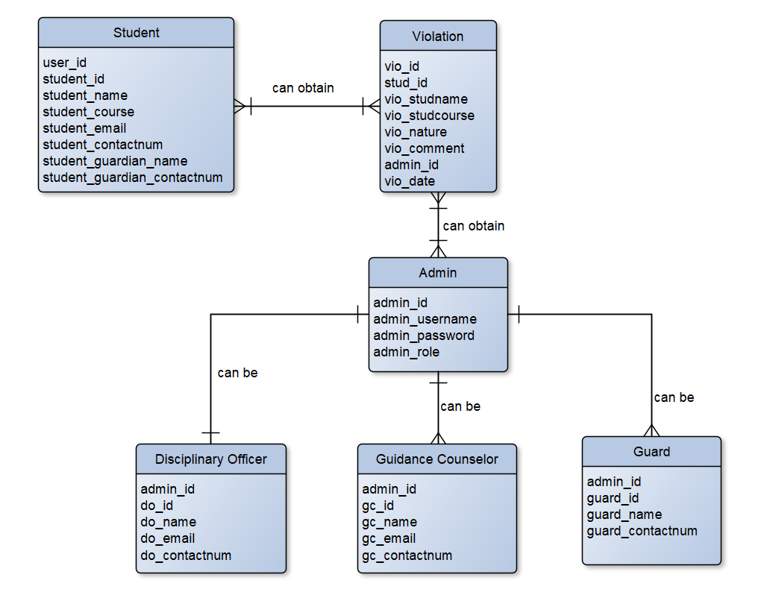

|  |  |  |  |
| --- | --- | --- | --- |
| Student | | | |
| stud_id | PK | Varchar(15) |  |
| stud_name | Not null | Varchar(80) |  |
| stud_course | Not null | Varchar(10) |  |
| stud_email | Not null | Varchar(50) |  |
| stud_contactnum | Not null | Varchar(11) |  |
| stud_guardian_name | Not null | Varchar(80) |  |
| stud_guardian_contactnum | Not null | Varchar(11) |  |
| stud_username | Not null | Varchar(10) |  |
| stud_password | Not null | Varchar(15) |  |

|  |  |  |  |
| --- | --- | --- | --- |
| Violation | | | |
| vio_id | PK | int(11) |  |
| stu_id | FK | varchar(15) |  |
| vio_studname | Not null | varchar(80) |  |
| vio_studcourse | Not null | varchar(30) |  |
| vio_nature | Not null | varchar(30) |  |
| vio_comment | Null | varchar(120) |  |
| admin_id | FK | varchar(15) |  |
| vio_date | Not null | Date |  |

|  |  |  |  |
| --- | --- | --- | --- |
| Admin | | | |
| admin_id | PK | varchar(15) |  |
| admin_username | Not null | varchar(10) |  |
| admin_password | Not null | varchar(15) |  |
| admin_role | Not null | varchar(50) |  |

1. Class diagram

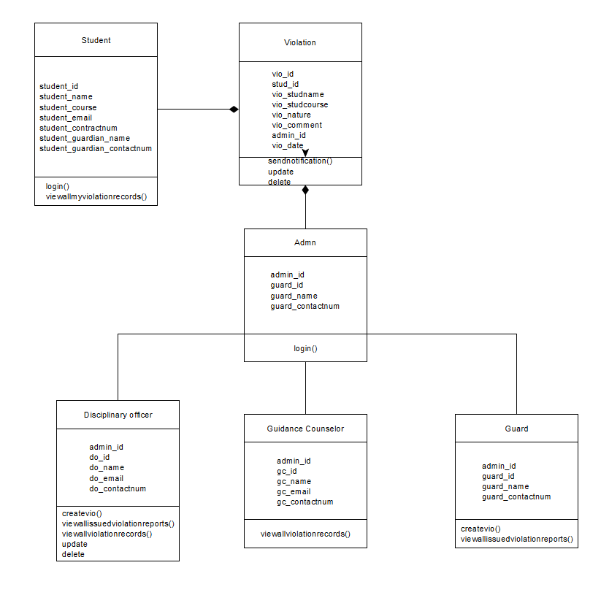

1. Activity

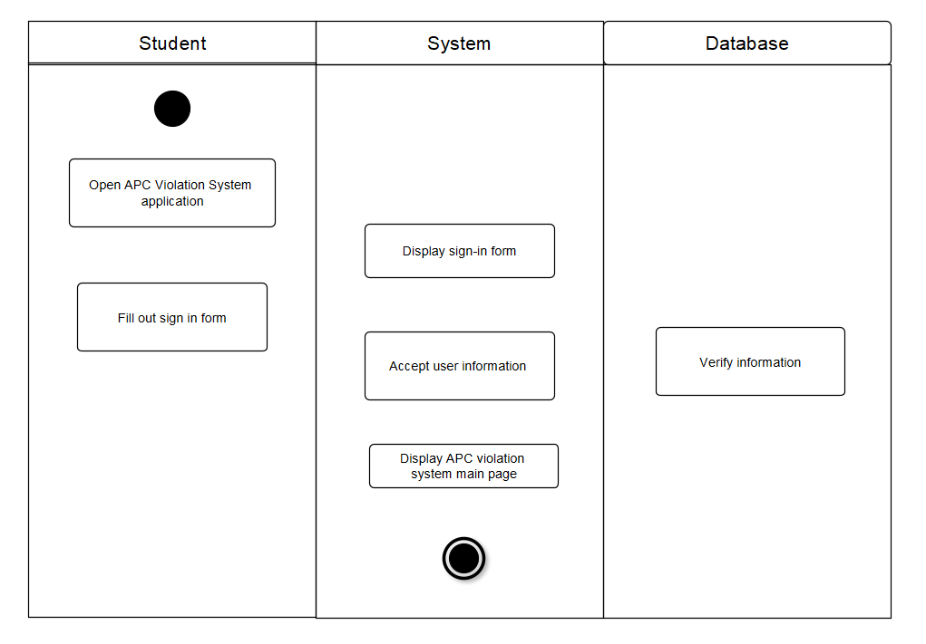

Student login

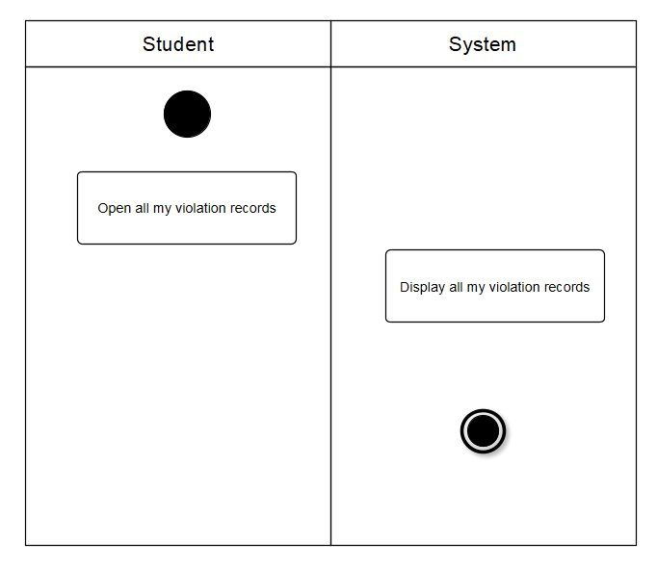

Student view all violation records

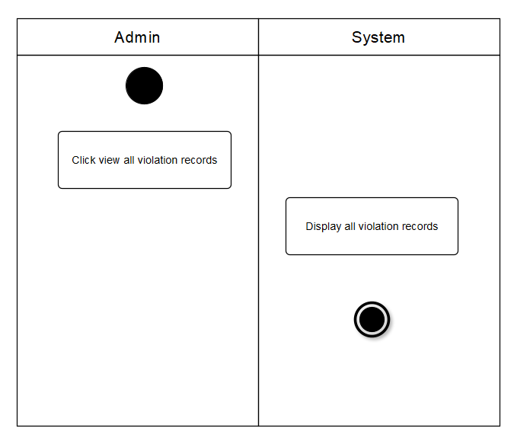

Admin view all violation records (DO, Guidance Counselor)

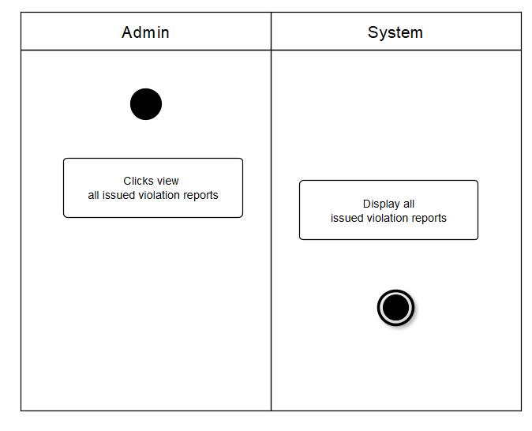

Admin View all Issued Violation Reports (DO, Guard)

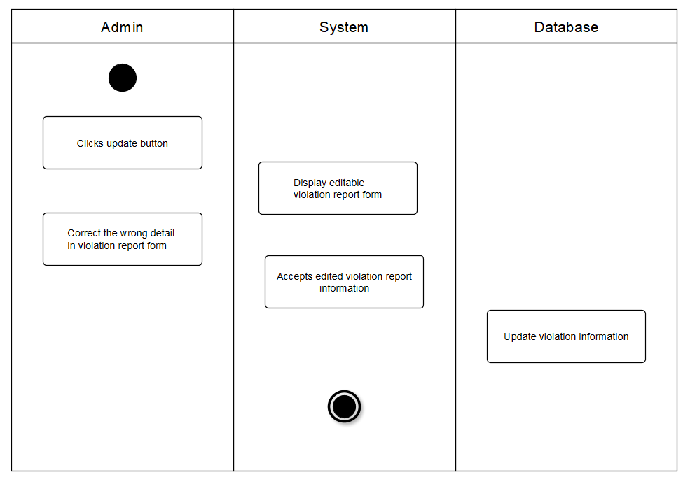

Admin update violation report (DO)

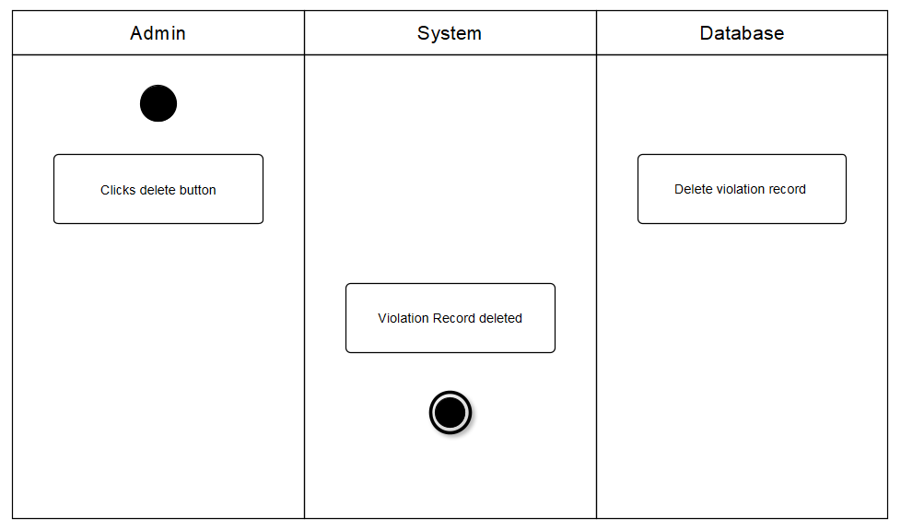

Admin delete violation report (D0)

1. Sequence

